

*Faculty of Engineering*

*Server Side Scripting Final Project Report*

CCE Department – Fourth year - French Section

Gym Management System: Enhancing Fitness Center Operations

Sarah Ghazal

70362

Supervised By Dr. Ali Bo Melhem

Acknowledgements

Throughout this journey, we have taken many efforts in this project. However, it would not have been possible without the kind support and help of many individuals and organisations. We would like to extend our sincere thanks to all of them.

We are highly indebted to the IUL’s CCE department for their guidance and constant supervision as well as for providing necessary information regarding the project and also for their support in its completion. We must express our gratitude towards our parents and close friends for their kind cooperation and encouragement which helped us in the completion of this project. Additionally, we give special gratitude and thanks to the IUL’s Library staff for their hospitality and assistance.

Table of Contents

1. Acknowledgements

2. Table of Contents

3. List of Figures

4. List of Tables

5. Abstract

6. General Introduction

7. Chapter 1: Literature Review

- Online Gym Management Systems

- Role of Technology in Fitness

8. Chapter 2: System Analysis

- Use-Case Diagram

- ER Diagram

9. Chapter 3: Database Implementation

10. Chapter 4: Software Implementation

- Database Connection

- Main Programming Tasks

- Sample Frames

11. Conclusion and Perspective

12. Bibliography

List of Figures

1. Sequence Diagram (Admin)

2. Sequence Diagram (Customer)

3. ER Diagram

4. Database Connection

5. Login Frame

6. Add Accounts

7. Manage Accounts

8. Dashboard Page (Admin Interface)

9. Dashboard Page (Customer Interface)

10.Dashboard Page (Trainer Interface)

11. Dashboard Page (Dietitian Interface)

List of Tables

1. Attendance
2. Classes
3. Feedbacks
4. Foods
5. Meal plans
6. User accounts
7. Workout plans

Abstract

**Gym Management System: Enhancing Fitness Center Operations** is an innovative platform designed to streamline and enhance the management of gym operations. This system provides a comprehensive solution for managing memberships, workout and meal plans, class scheduling, and feedback, fostering an efficient fitness environment. Key features include role management, where different user roles (admins, trainers, dietitians, customers) have specific functionalities. The system facilitates the creation and viewing of workout and meal plans, enabling trainers and dietitians to provide personalised plans to customers. Additionally, it allows for easy scheduling and management of classes and collection of feedback. The user interface is designed to be intuitive and user-friendly, providing a seamless experience for all users. This system aims to empower the fitness journey of customers by providing a robust platform that integrates various gym management functionalities, ultimately enhancing the overall gym experience.

General Introduction

This report will summarise all the aspects of our work during this training.

The application itself was built using:

* PHP/HTML/CSS code
* MySQL (Database Tables)
* Power Builder/ Lucid Chart (Software Engineering Diagrams)

The system functions are of two types:

A-Customer:

1. View and follow workout and meal plans.
2. Manage personal fitness details.
3. Provide feedback on trainers, dietitians, and the gym.

B-Admin:

1. Manage user accounts and roles.
2. Schedule and manage gym classes.
3. Oversee the creation and distribution of workout and meal plans.
4. Perform additional administrative tasks like updating user records.

Concerning the functional requirements:

1. Customer Interface:

* 1. - Customers should be able to view and follow their workout and meal plans.
  2. - Customers should have access to detailed fitness records.
  3. - Customers should be able to manage and update their personal fitness details.
  4. - Customers should have a seamless navigation experience to find the information they need quickly.

2.Class Management:

* 1. - Administrators should be able to view and manage details of classes.
  2. - Administrators should have the ability to add new classes or remove existing ones.
  3. - Administrators should be able to keep the class schedule up-to-date to reflect current offerings.

3.Workout and Meal Plans:

* 1. - Trainers and dietitians should be able to create personalised workout and meal plans for customers.
  2. - Plans should be easily accessible and understandable for customers.
  3. - The system should facilitate the management and distribution of these plans.

As for the Non-Functional Requirements:

* Reliability and Accuracy:
  + The system must be reliable and accurately capture and treat data to prevent loss of information or mismanagement of gym resources which could impact the gym's operations.
* Availability:
  + System availability is crucial to ensure continuous access to gym resources and management functions.
* Portability/Mobility:
  + The system needs to be accessible from mobile and portable devices to accommodate users outside traditional settings.
* Security:
  + Security is essential across different parts of the system including administration. It should include roles and authorizations, logging all actions, and securing access from mobile and portable devices.

Chapter 1: Literature Review

Online Gym Management Systems

Gym management systems streamline operations, enhance customer service, and improve overall management for fitness centres. Below is a summary of key features and benefits of prominent gym management systems.

Mindbody

Features:

- Class scheduling, membership management, customer management, POS, and mobile app.

Benefits:

- Comprehensive integration, ease of use, and enhanced customer engagement.

Glofox

Features:

- Class and membership management, marketing tools, analytics, and mobile app.

Benefits:

- Streamlined operations, enhanced marketing, and data-driven decisions.

Zen Planner

Features:

- Membership management, class scheduling, performance tracking, automated billing, and customizable reports.

Benefits:

- Efficient member management, improved member retention, and financial management.

GymMaster

Features:

- Membership management, access control, booking system, CRM, and mobile app.

Benefits:

- Enhanced security, improved customer relationships, and increased convenience.

Wodify

Features:

- Class management, performance tracking, billing, member engagement, and mobile app.

Benefits:

- Enhanced member experience, efficient operations, and engagement tools.

These systems provide comprehensive tools for managing gym operations, improving efficiency, increasing member satisfaction, and supporting business growth. Each system offers unique strengths tailored to different needs.

Chapter 2: System Analysis

Sequence Diagram

Admin Sequence Diagram:

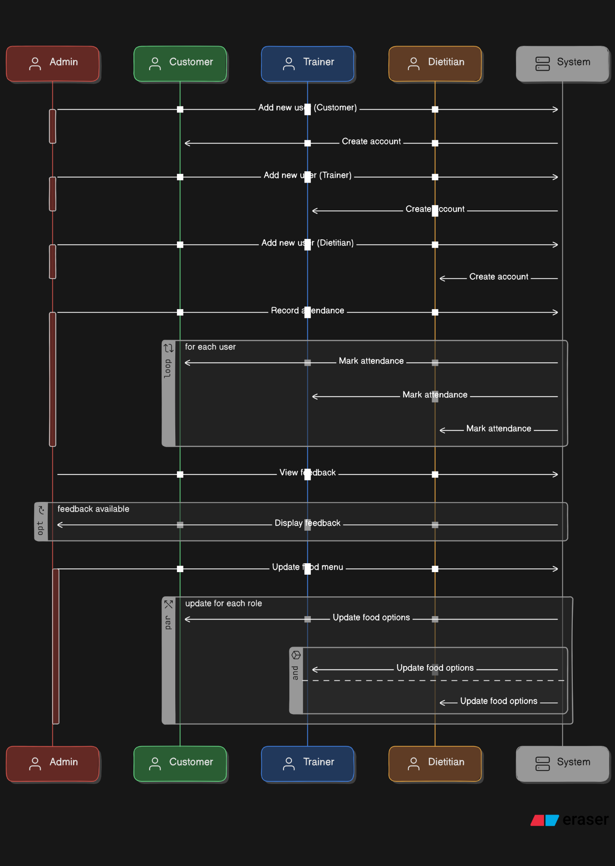

Customer Sequence Diagram:

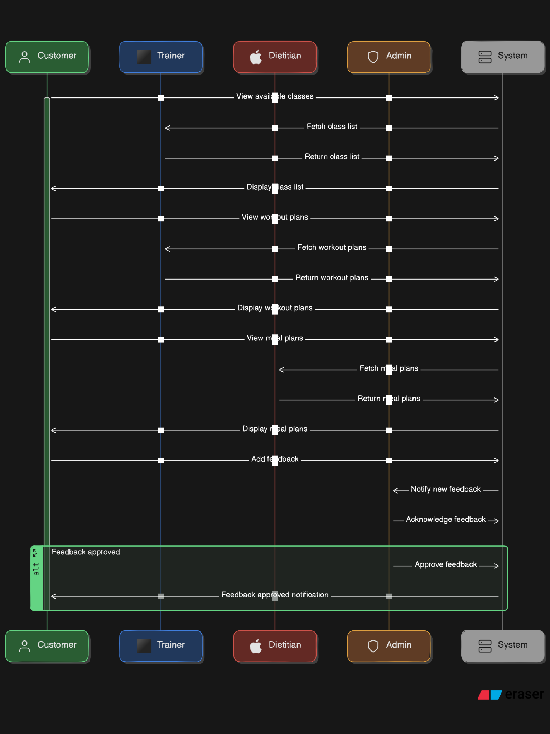

ER Diagram

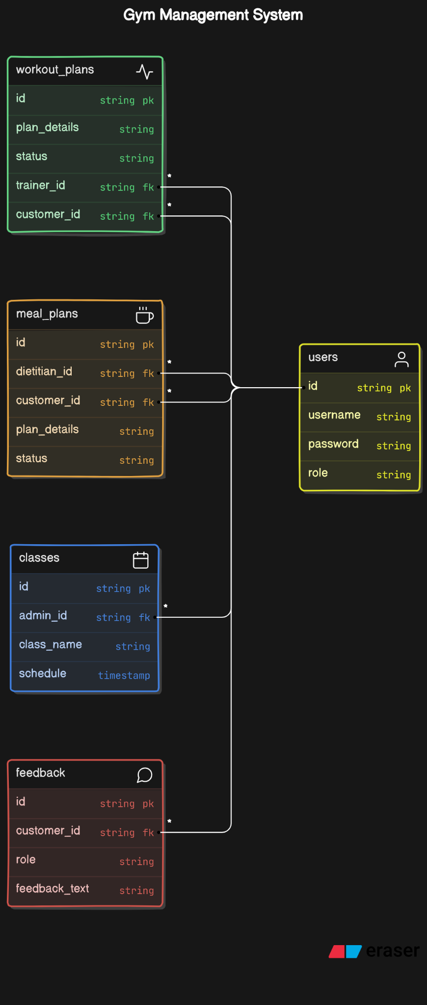

Chapter 3: Database Implementation

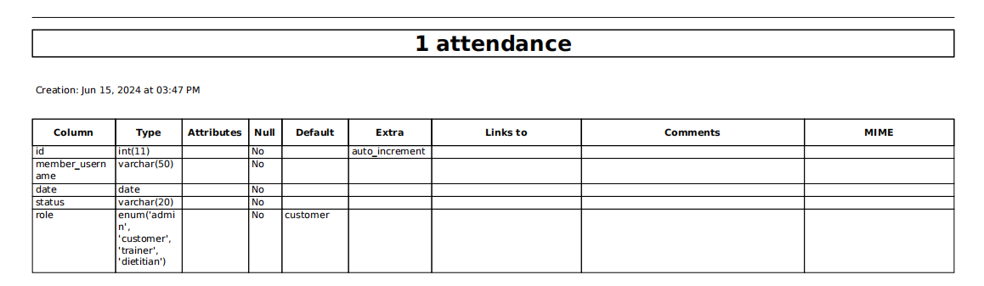

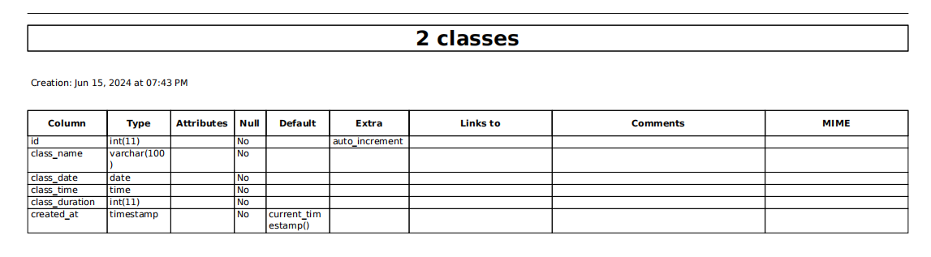

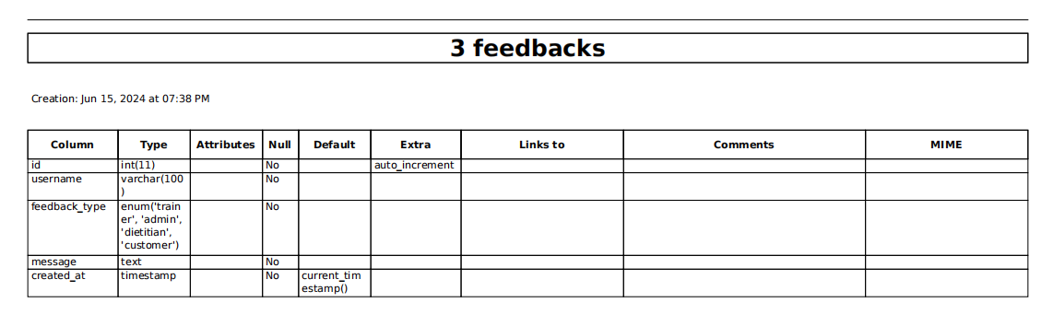

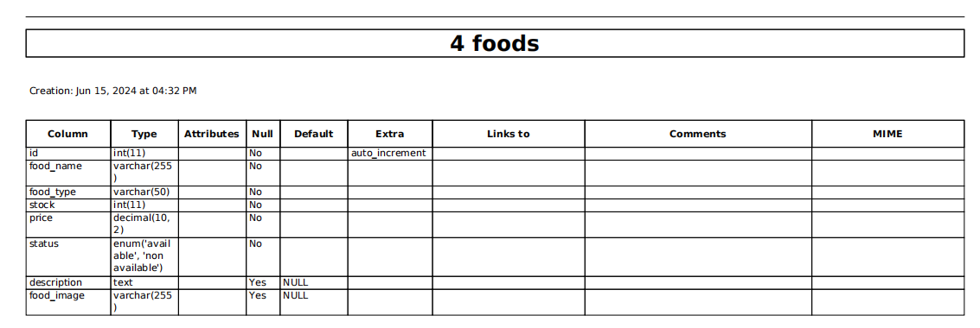

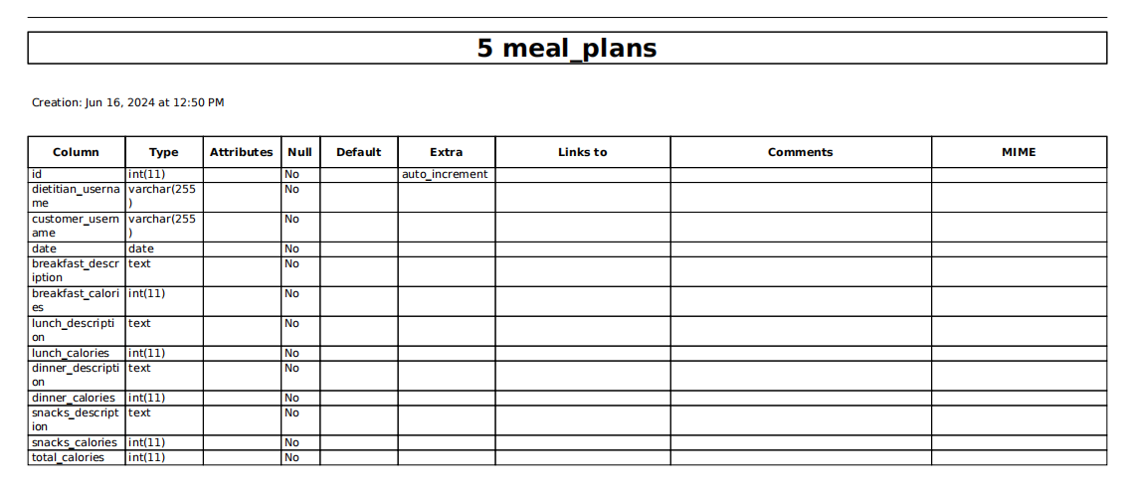

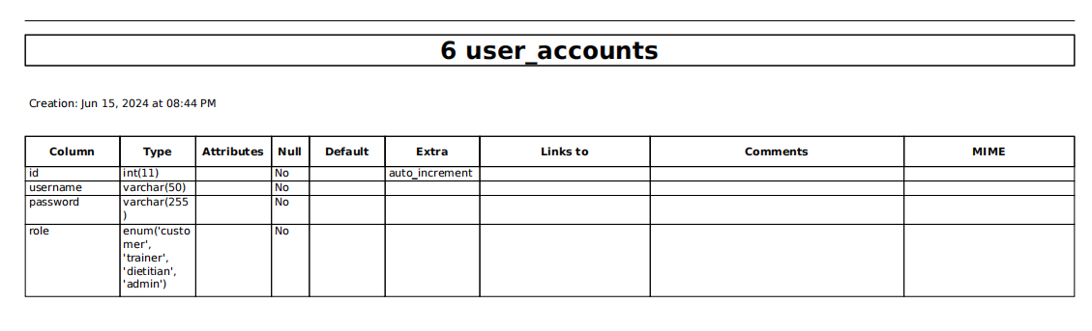

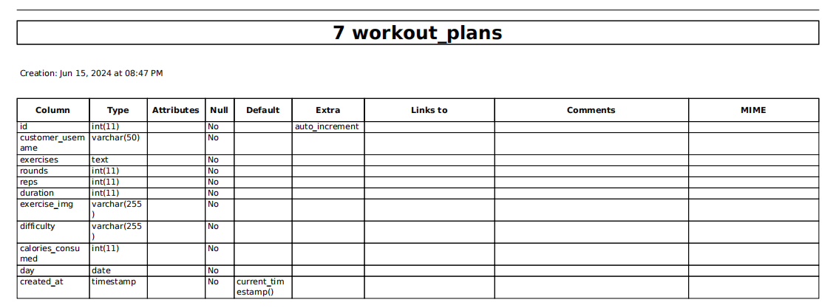

Chapter 4: Software Implementation

Database Connection

<?php

// Database connection settings

$servername = "localhost";

$username = "root";

$password = "";

$dbname = "fitness_gym";

// Create connection

$conn = new mysqli($servername, $username, $password, $dbname);

// Check connection

if ($conn->connect_error) {

die("Connection failed: " . $conn->connect_error);

}

echo "Connected successfully";

?>

Main Programming Tasks

| Programming Task | Details |
| --- | --- |
| External Packages | Packages used for design and animation |
| SQL Queries | Database connection and queries |
| PHP Coding | Backend development |
| HTML/JavaScript/CSS | Frontend development |

Sample Frames

Login Frame:



Create Account Frame:

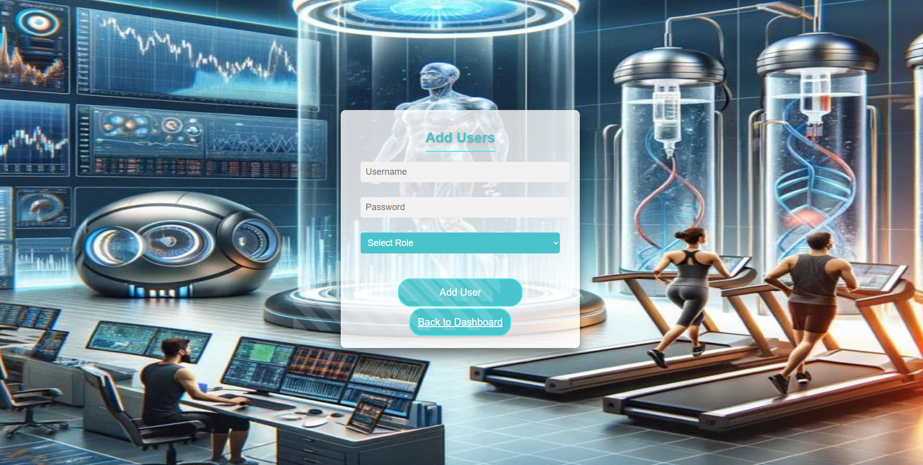

Dashboard Page (Admin Interface):

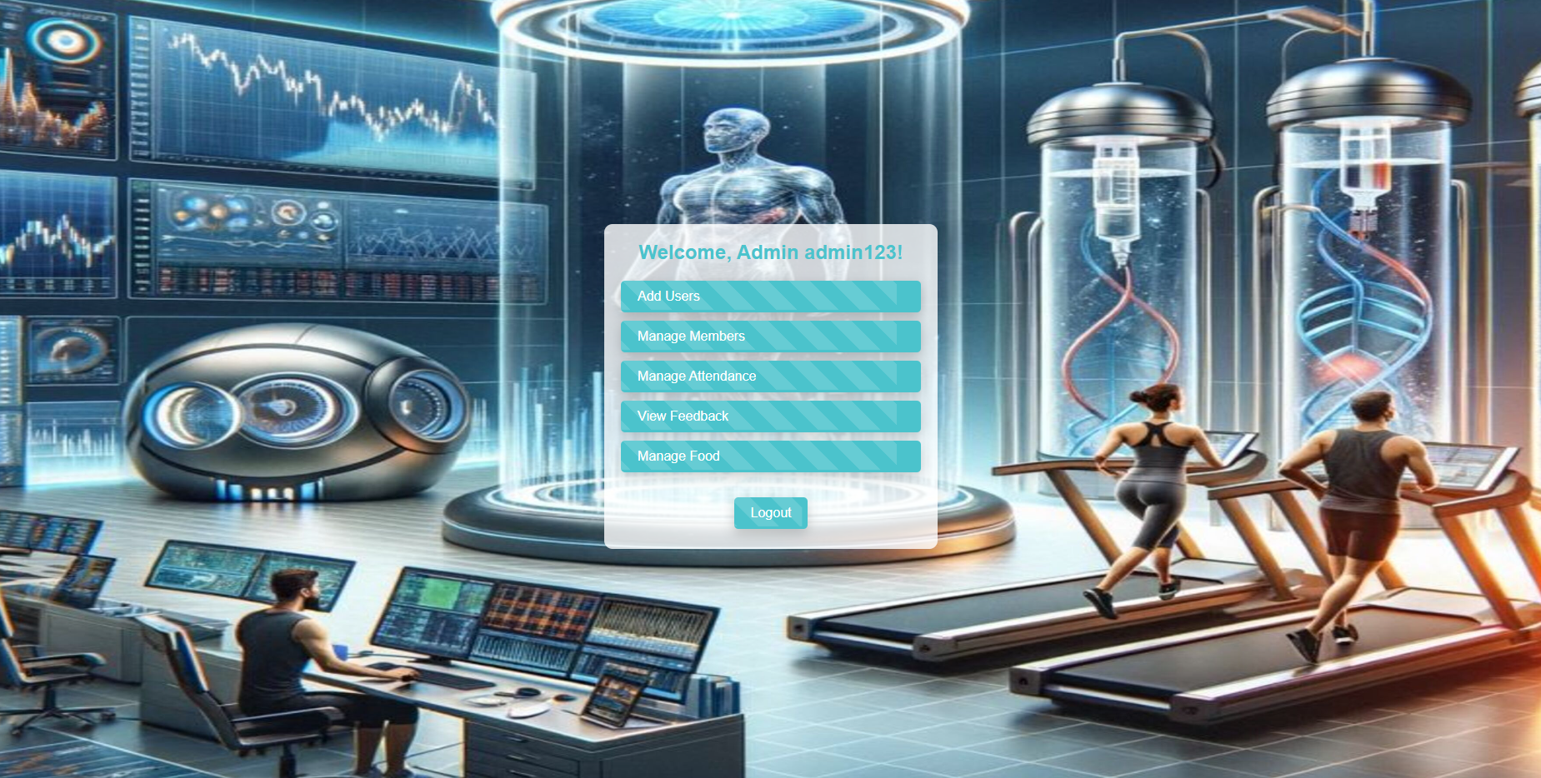

Manage Members:

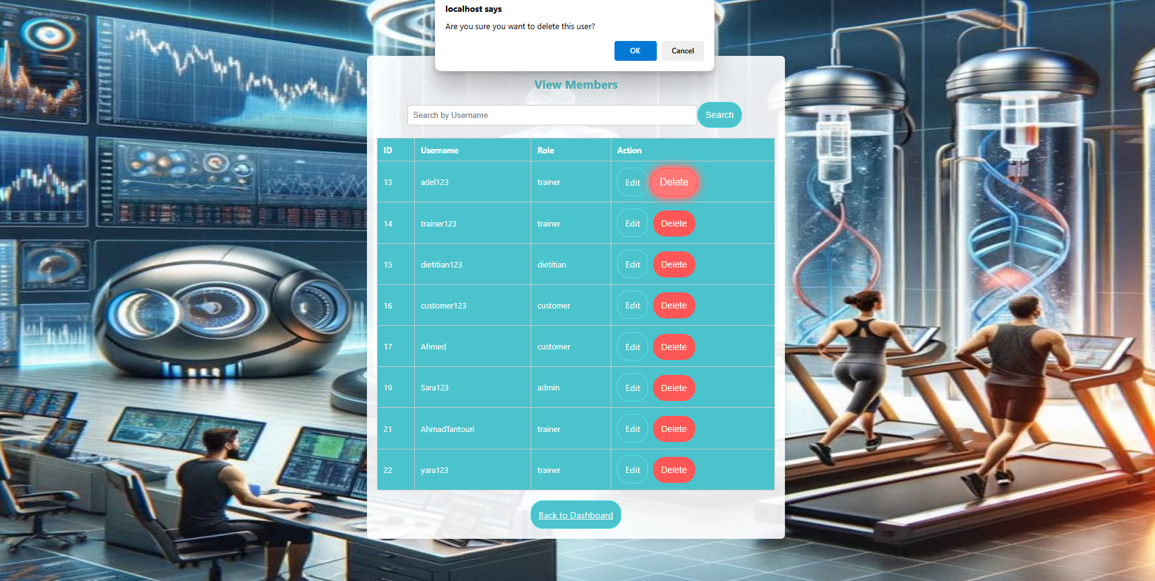

Manage Attendances:

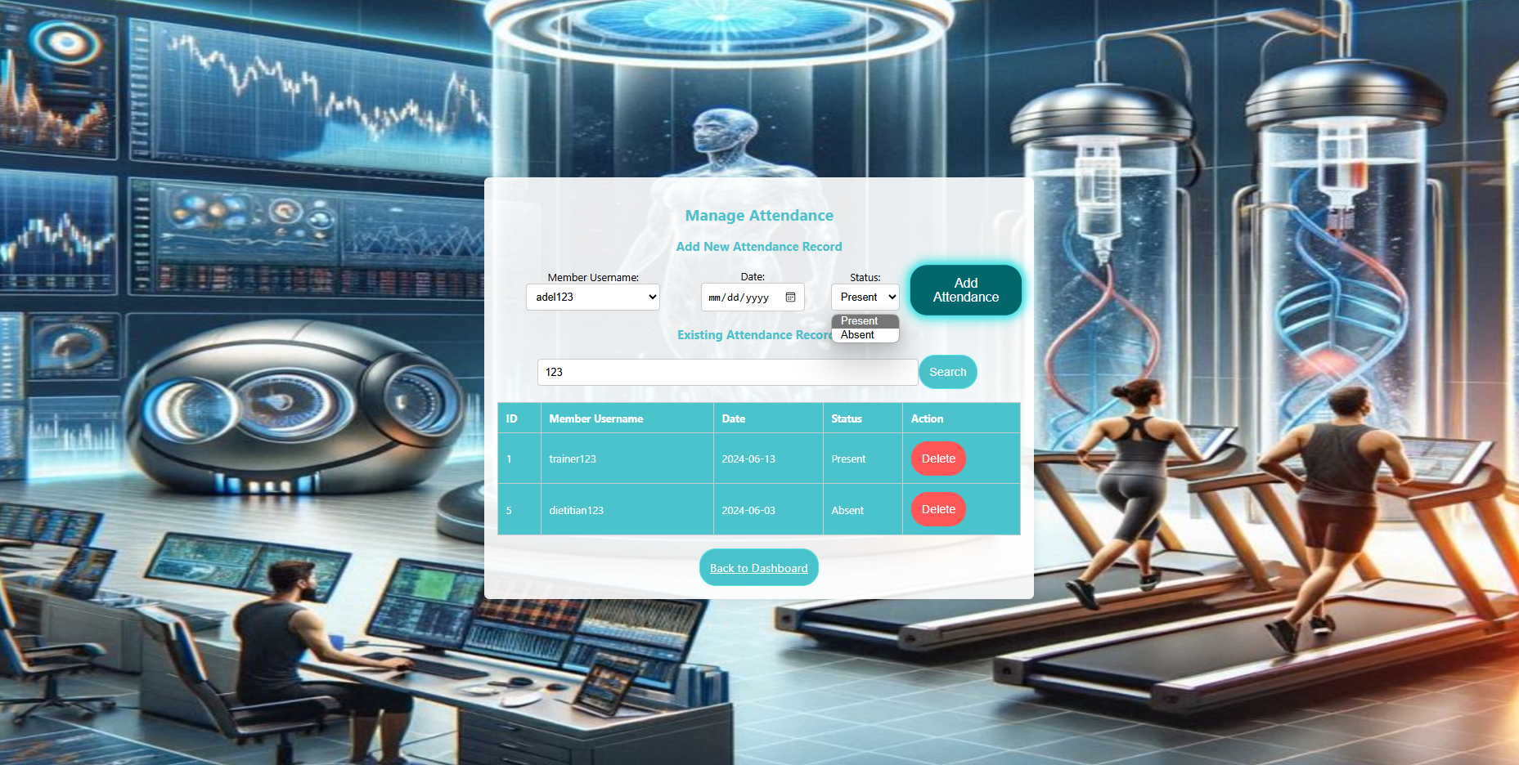

View Feedback:

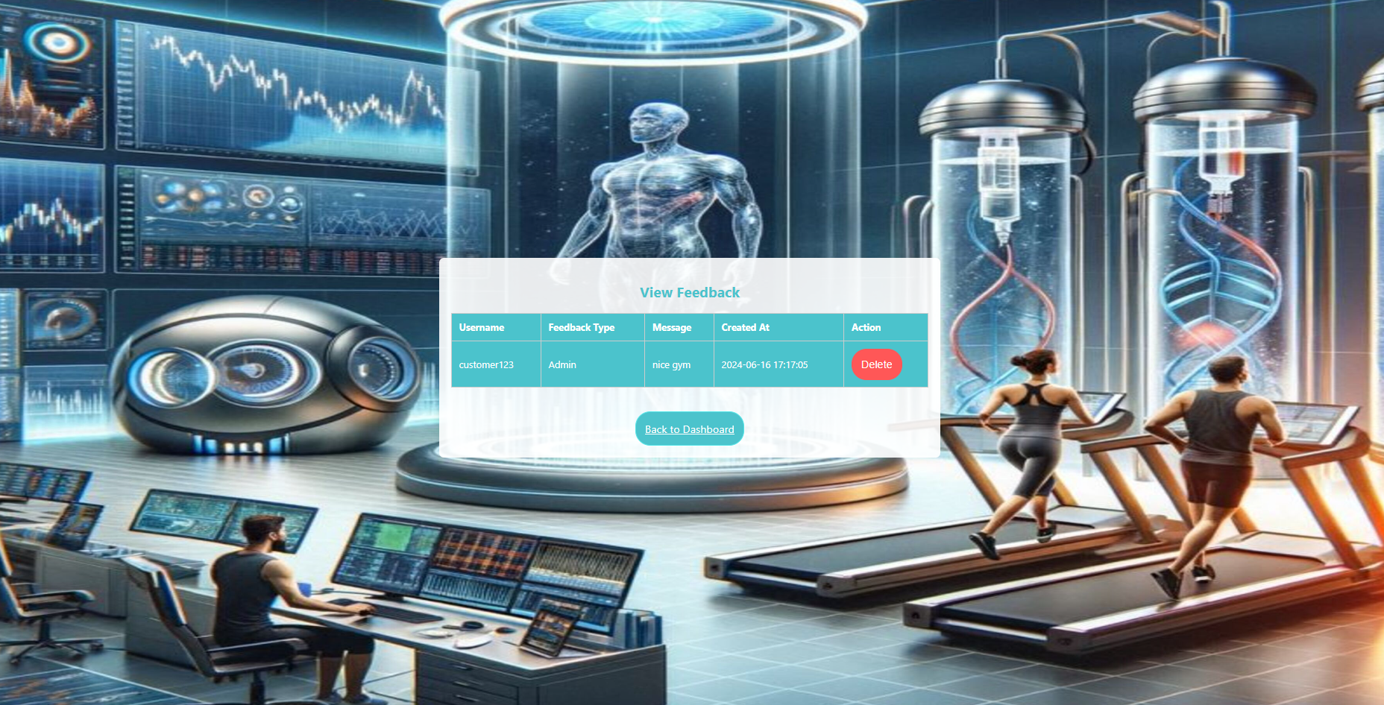

Manage Foods :

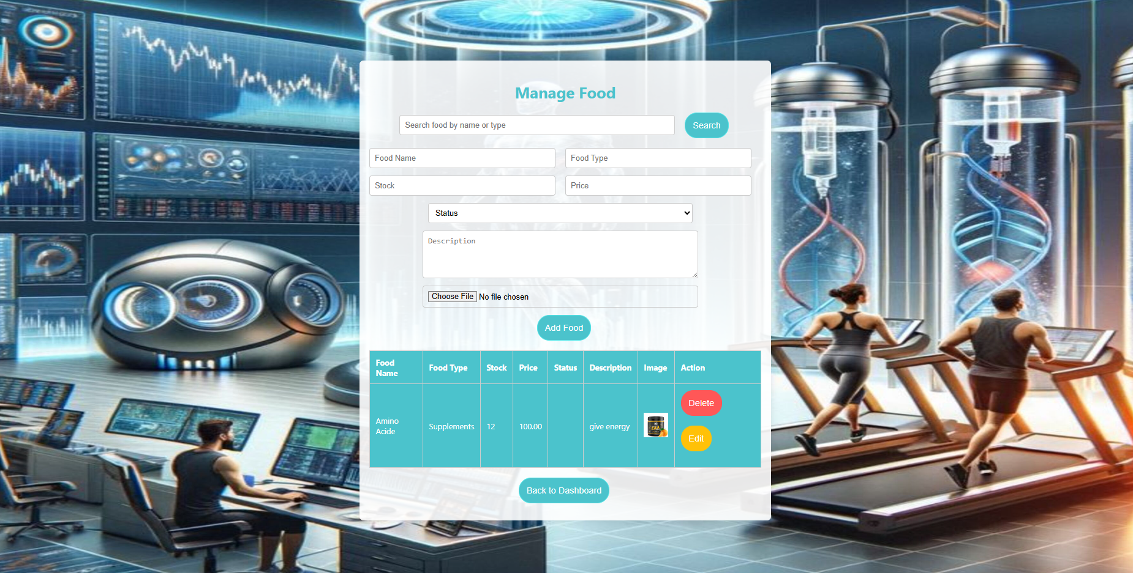

Dashboard Page (Customer Interface):

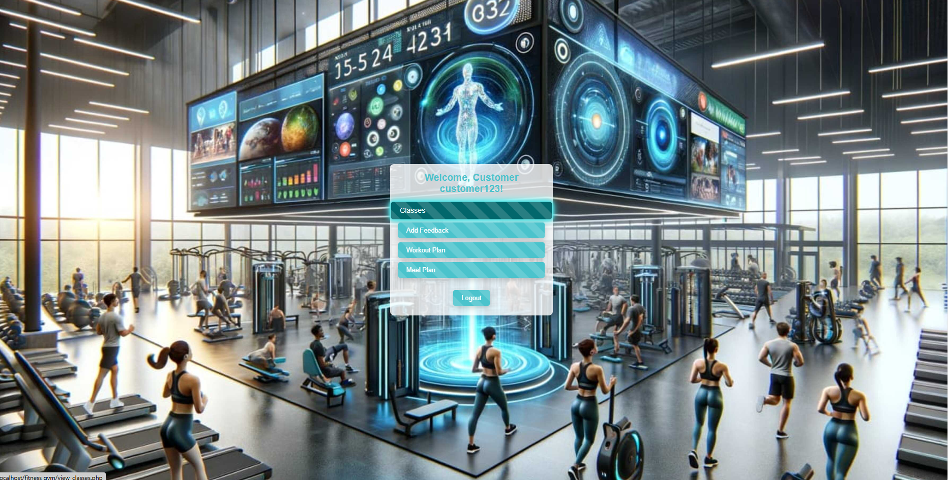

View Classes Page:

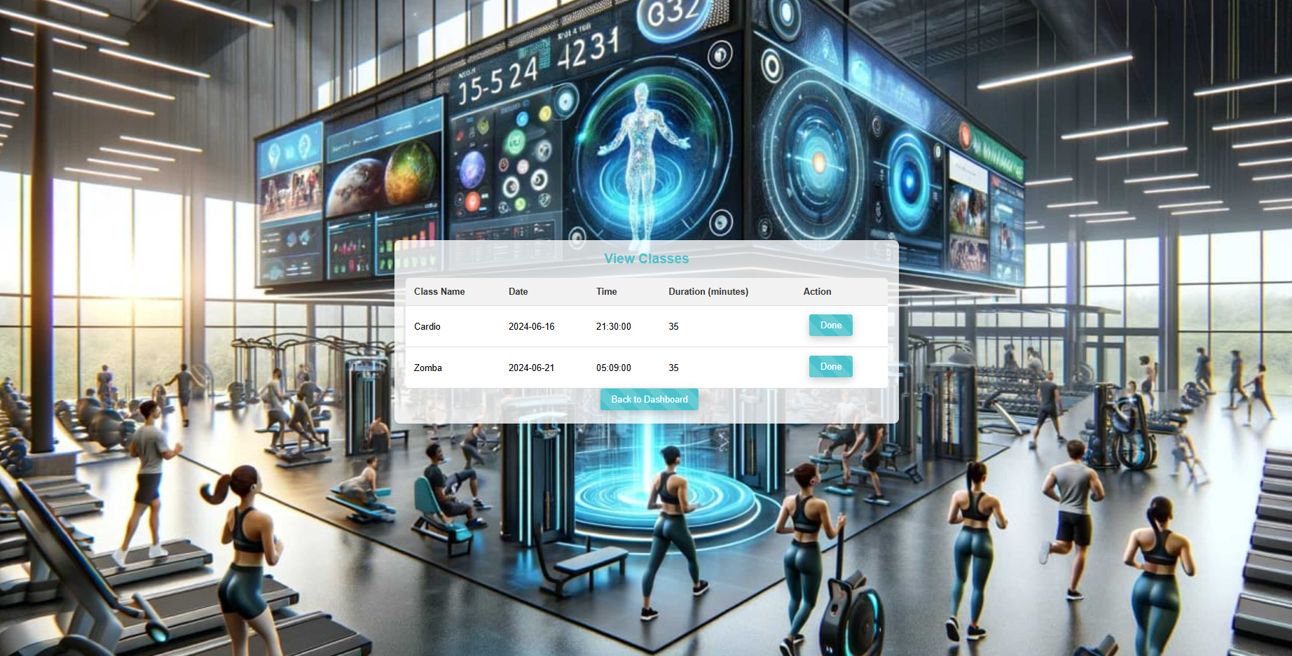

Add Feedback Page:

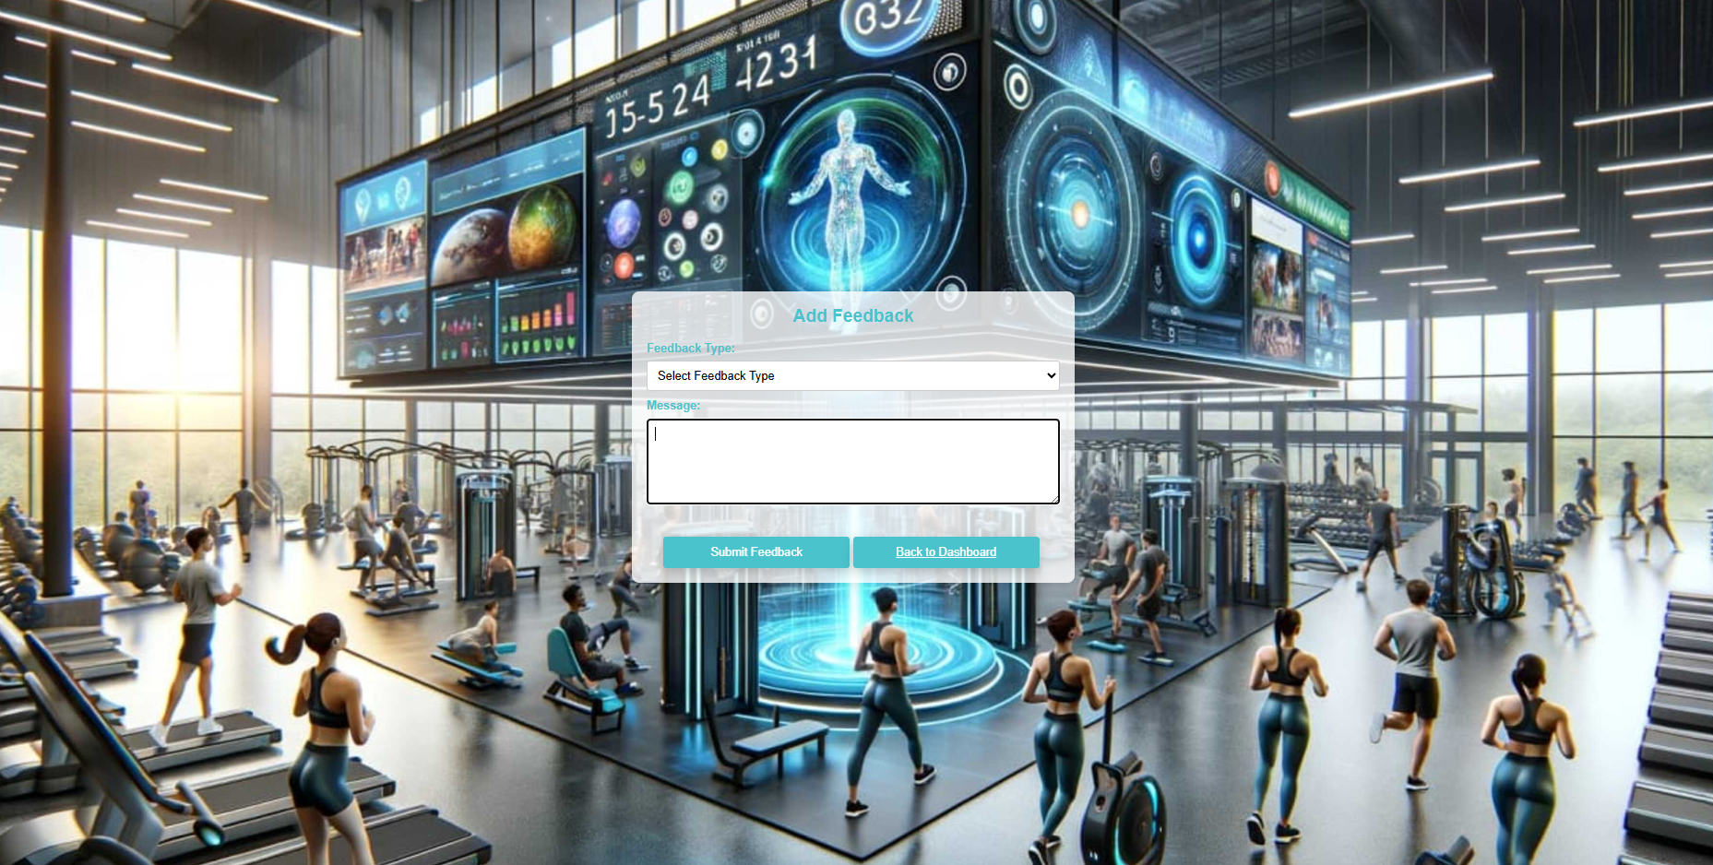

View Workout Plan Page:

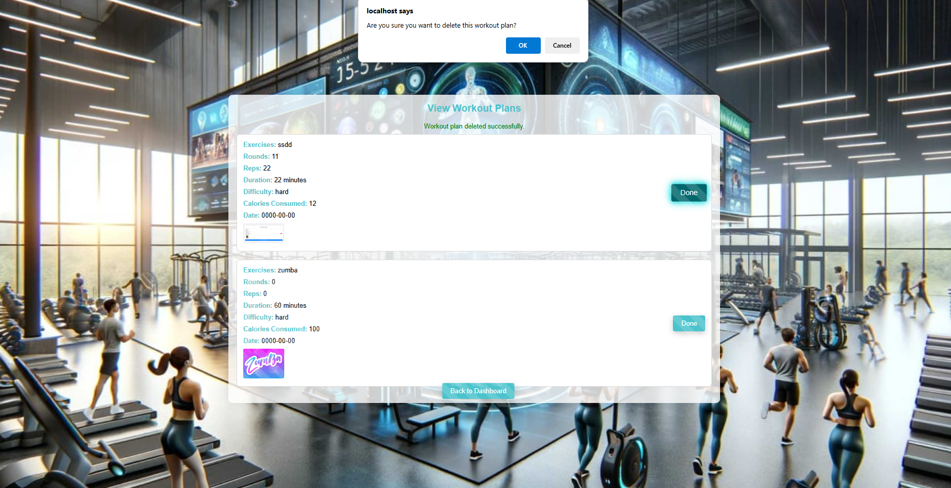

View Meal Plan Page:

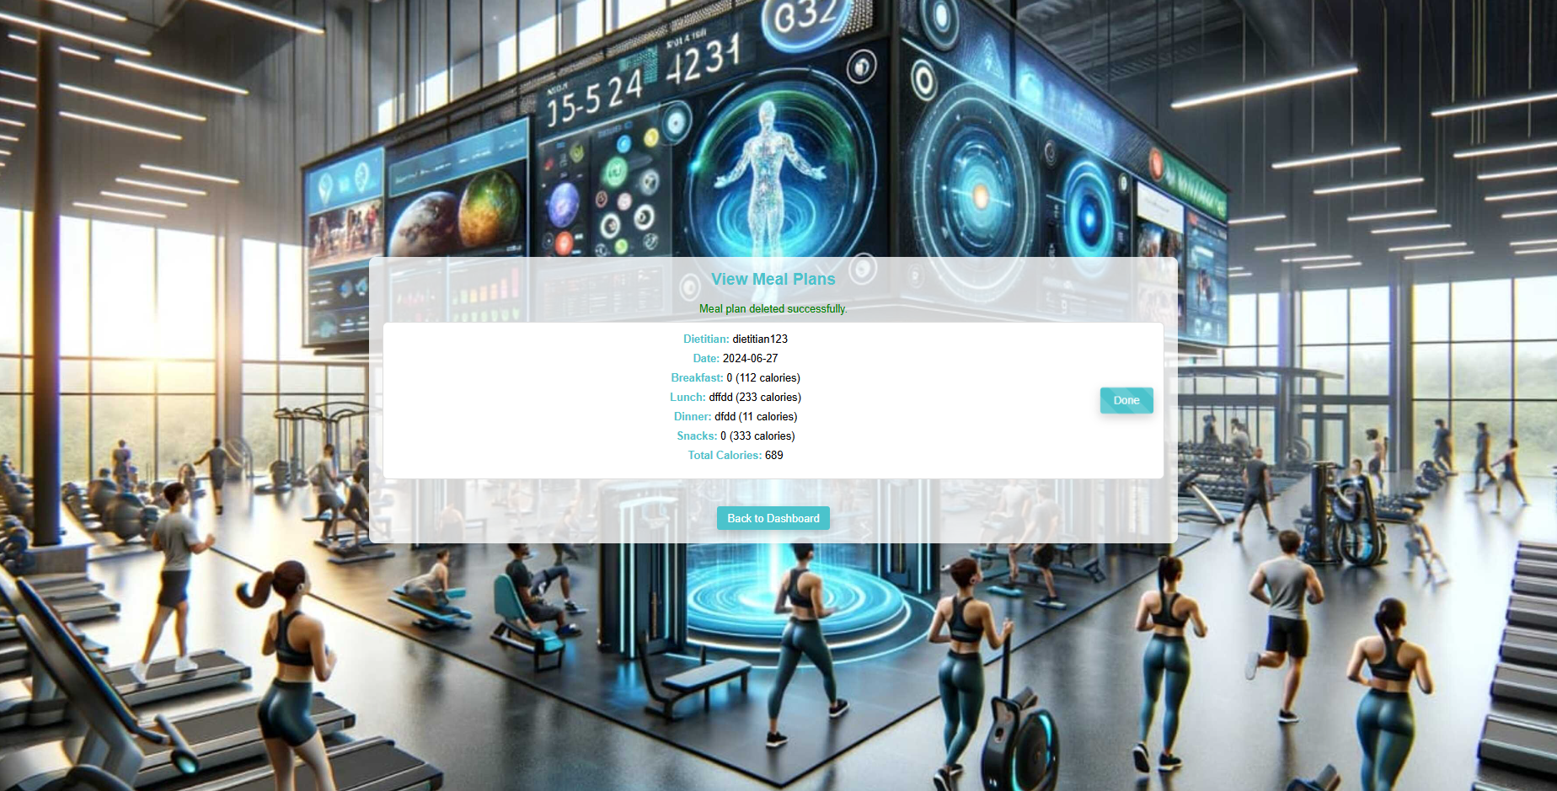

Dashboard Page (Trainer Interface):



Add Classes:

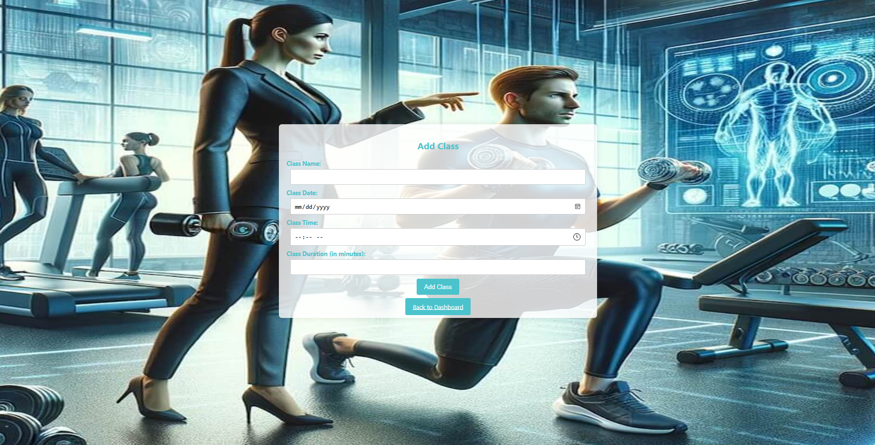

Send Workout Plan:

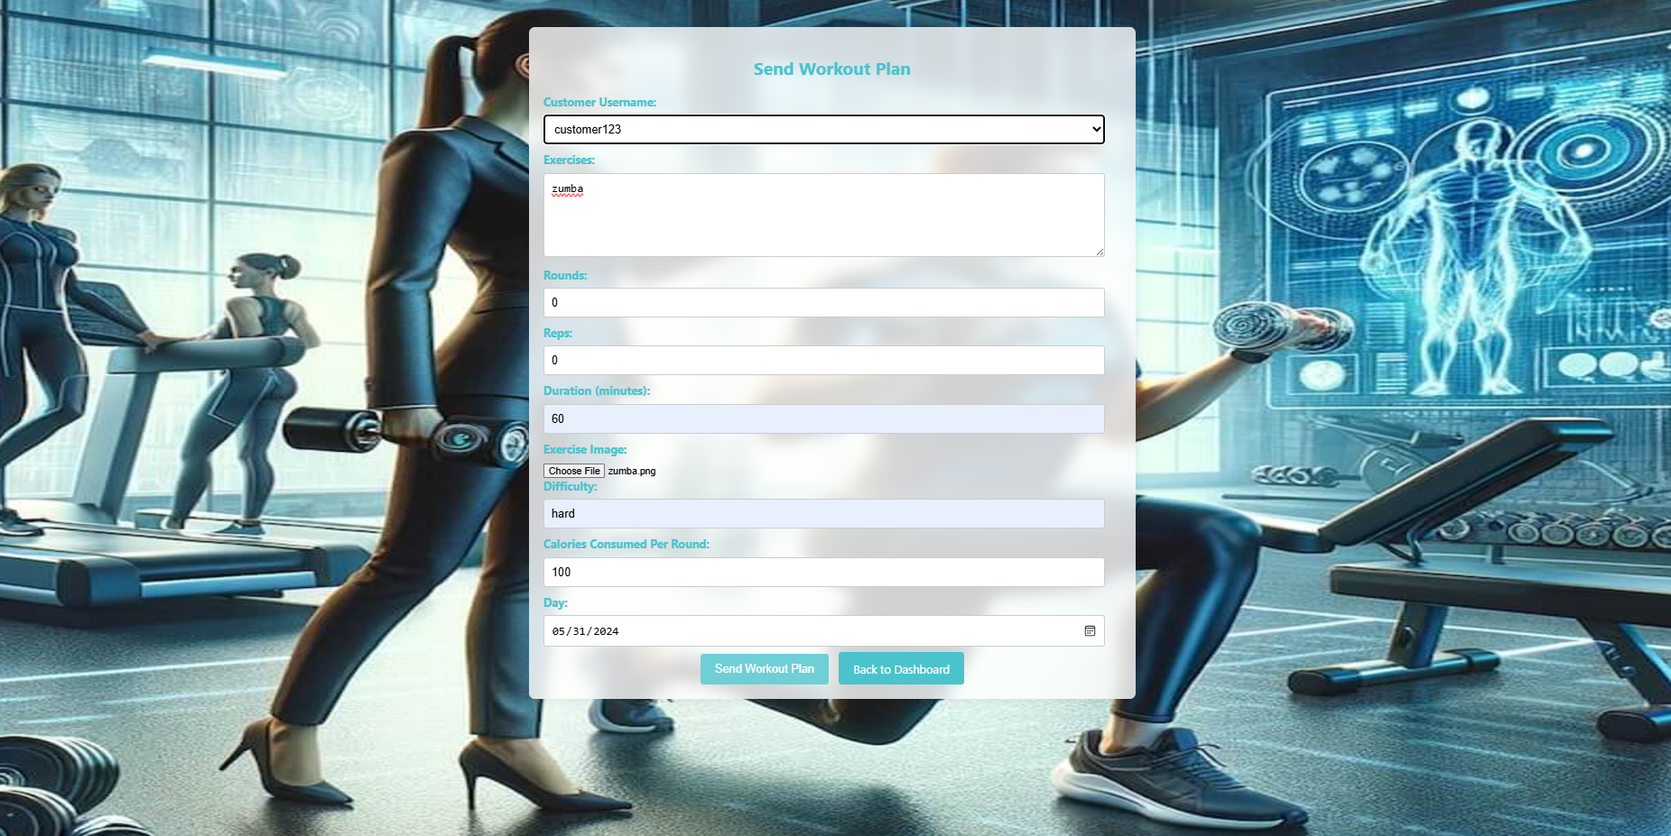

Dashboard Page (Dietitian Interface):



Send Meal Plan:

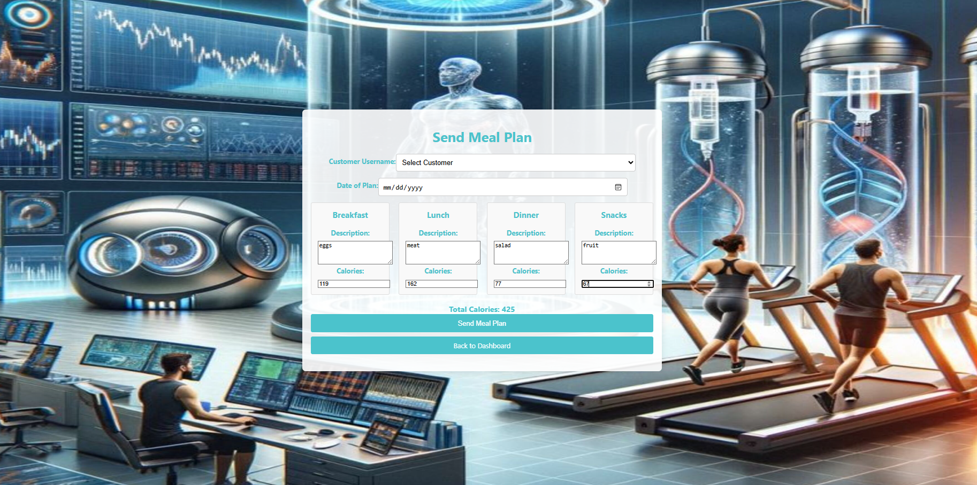

Brief Explanation of Each Page in the Gym Management System

1. Login Page

- Purpose: Allows users (admins, trainers, dietitians, and customers) to log into the system.

- Features:

- User authentication.

- Redirects to the respective dashboard based on user role.

2. Admin Dashboard

- Purpose: Central hub for admin operations.

- Features:

- Manage user roles and permissions.

- View and manage classes.

- Oversee overall system functionality.

3. Trainer Dashboard

- Purpose: Interface for trainers to manage workout plans and track customer progress.

- Features:

- Create and view workout plans for customers.

- Monitor customer performance and progress.

- Schedule and manage training sessions.

4. Dietitian Dashboard

- Purpose: Interface for dietitians to manage meal plans and monitor dietary progress of customers.

- Features:

- Create and view personalised meal plans.

- Monitor customer dietary adherence and progress.

- Adjust meal plans based on feedback and progress.

5. Customer Dashboard

- Purpose: Main interface for customers to interact with their fitness plans and provide feedback.

- Features:

- View assigned workout plans and meal plans.

- Submit feedback on trainers, dietitians, and classes.

- Track personal fitness progress.

6. View Classes Page

- Purpose: Allows users to view all available gym classes.

- Features:

- Displays class name, date, time, and duration.

- "Done" button to mark attendance and delete the class from the list.

7. Workout Plan Page

- Purpose: Customers can view detailed workout plans provided by trainers.

- Features:

- Displays exercises, rounds, reps, duration, images, and difficulty level.

- "Done" button to mark workout completion.

8. Meal Plan Page

- Purpose: Customers can view detailed meal plans provided by dietitians.

- Features:

- Displays descriptions and calorie counts for breakfast, lunch, dinner, and snacks.

- Shows total daily calories.

- "Done" button to acknowledge the meal plan.

9. Add Feedback Page

- Purpose:Customers can provide feedback on various aspects of the gym services.

- Features:

- Form to submit feedback for trainers, admins, dietitians, or the overall gym experience.

- Stores feedback in the database for review by relevant personnel.

10. Class Scheduling Page

- Purpose: Admins can schedule new classes and manage existing ones.

- Features:

- Form to add new classes with details like class name, date, time, and duration.

- List of scheduled classes with options to edit or delete.

11. Database Connection Script

- Purpose: Establishes a connection to the MySQL database.

- Features:

- Includes credentials and connection logic.

- Ensures secure and efficient database interactions.

12. User Registration Page

- Purpose: Allows new users to register and create an account.

- Features:

- Registration form with fields for username, password, and role selection.

- Validations to ensure data integrity.

Conclusion and Perspective

Problems/Technical Issues Faced:

* Transferring coding files between computers.
* Database hosting.
* Creating access for users to install the application.
* Handling errors from external packages and libraries.

(All problems listed above have been solved.)

Perspective:

Plans for the future development of this application include:

* Developing a mobile app for easier access.
* Simplifying the code to decrease runtime.
* Changing data types used in the database to smaller ones to reduce memory usage.

Concluding Statement:

As we conclude this report and reflect on the **Gym Management System** project, it is evident that the system has met all expectations and achieved goals beyond the initial scope. The problem posed "how can we streamline and enhance the management of gym operations?" has been thoroughly addressed. This application provides an efficient solution for managing memberships, workout and meal plans, class scheduling, and feedback, making gym resources more accessible and administrative tasks more manageable. We have completed our tasks and delivered a solution that empowers the fitness journey of both customers and gym staff. The next step is yours! Embrace this system and enhance your gym experience with the **Gym Management System**.

Bibliography

W3Schools Online Web Tutorials.Available at: [W3Schools](https://www.w3schools.com/)

- Valuable resource for HTML, CSS, and JavaScript tutorials.

Bootstrap Documentation. Available at: [Bootstrap](https://getbootstrap.com/docs/)

- Implemented responsive design elements using Bootstrap.

GitHub Repositories and Open Source Projects.

- Examples and best practices from various repositories.

Stack Overflow.Available at:

[Stack Overflow](https://stackoverflow.com/)

- Crucial for troubleshooting and quick solutions.

Research Articles on Gym Management Systems.

- Reviewed to understand trends, strengths, and weaknesses in existing systems.